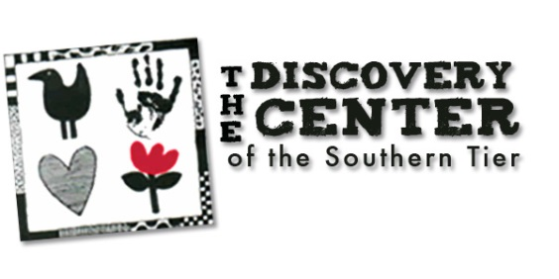
Join Our Board of Directors

Thank you for your interest in serving on the Board of Directors at The Discovery Center of the Southern Tier. Becoming a board member is an opportunity to make a significant difference in the lives of children.
Our Mission: “The Discovery Center of the Southern Tier is committed to creating an environment that fosters the intellectual, physical, and emotional well-being of children through education, participatory exhibits and programs.

“We offer diversion; we offer fun; we offer love and a happy day. Come often, stay as long as you’d like and enjoy every minute. And know that everyone has a special place in our hearts.” ~ Pokey Crocker, Executive Director 1988-2016

Now in our 4th decade, The Discovery Center is a hands-on interactive children’s museum serving the Southern Tier of New York and Northeastern Pennsylvania. This remarkable 22,500 square foot space was created for, with and by children. Play and learning flow together in unique hands-on settings designed with imagination, research and attention to the needs and spirit of today’s learners. Offering a safe, engaging and happy atmosphere The Discovery Center fosters play, sparks creative thinking and builds self-esteem. Our exhibits, our themes and our ambiance are community specific, yet we leave a wide margin for global discovery.
The Discovery Center Board of Directors is an integral part of furthering the agency’s mission and goals. The key functions of the Board of Directors are:
▪ To protect the public interest (governance, evaluation, ensure legal and ethical integrity).
▪ To ensure the organization achieves its mission and goals (select, support, and evaluate the Executive Director, ensure effective planning, collaborating with staff, strategic and financial planning for sustainability).
▪ To enhance the organization’s public standing (communicate the mission to the public, garner support from the community),
▪ To cultivate and leverage connections and resources that can further initiatives (industry/ community connections, planning and executing fundraising events).
▪ To bring forth new ideas and enthusiasm, and to work to make these ideas a reality.

Board meetings are held at the Discovery Center on the fourth Tuesday nine times a year with a planning session at 5:30 p.m. and the Board meeting beginning at 6:15 p.m.
For more information about The Discovery Center, or serving on the Board of Directors, please visit www.thediscoverycenter.org, or contact our Executive Director, director@thediscoverycenter.org. If you are interested in being considered for one of our Board openings, please complete the attached application form and return it via email to discoverycenterboard@gmail.com, or mail to: Nominations, The Discovery Center, 60 Morgan Rd, Binghamton NY 13903.

The Discovery Center of the Southern Tier
Board Application Form

Date: ________________________ Nominator (if any): __________________________________________
Name: _______________________________________________ Phone: ____________________________
Mailing Address__________________________________________________________________________
E-Mail: _________________________________________________________________________________
Relevant experience and/or employment (attach a resume if relevant) ______________________________
_______________________________________________________________________________________
_______________________________________________________________________________________
_______________________________________________________________________________________
_______________________________________________________________________________________
_______________________________________________________________________________________
Why are you interested in our organization? __________________________________________________
_______________________________________________________________________________________
_______________________________________________________________________________________
_______________________________________________________________________________________
Area(s) of expertise/contribution you feel you can make _________________________________________
_______________________________________________________________________________________
_______________________________________________________________________________________
_______________________________________________________________________________________
_______________________________________________________________________________________
Other volunteer commitments ______________________________________________________________
_______________________________________________________________________________________
_______________________________________________________________________________________
_______________________________________________________________________________________
_______________________________________________________________________________________
Thank you for completing this application for board membership. We will be in touch with you shortly.
For Board Use
 Candidate has received recruitment package. Date: _________
 Candidate has had a personal discussion with nominating committee chair. Date: _________
 Candidate reviewed by the committee. Date: _________
 Candidate attended a board meeting. Date: _________

